The Catholic Faith Communities of
Saint Theresa-St. Christopher
Tiverton, RI

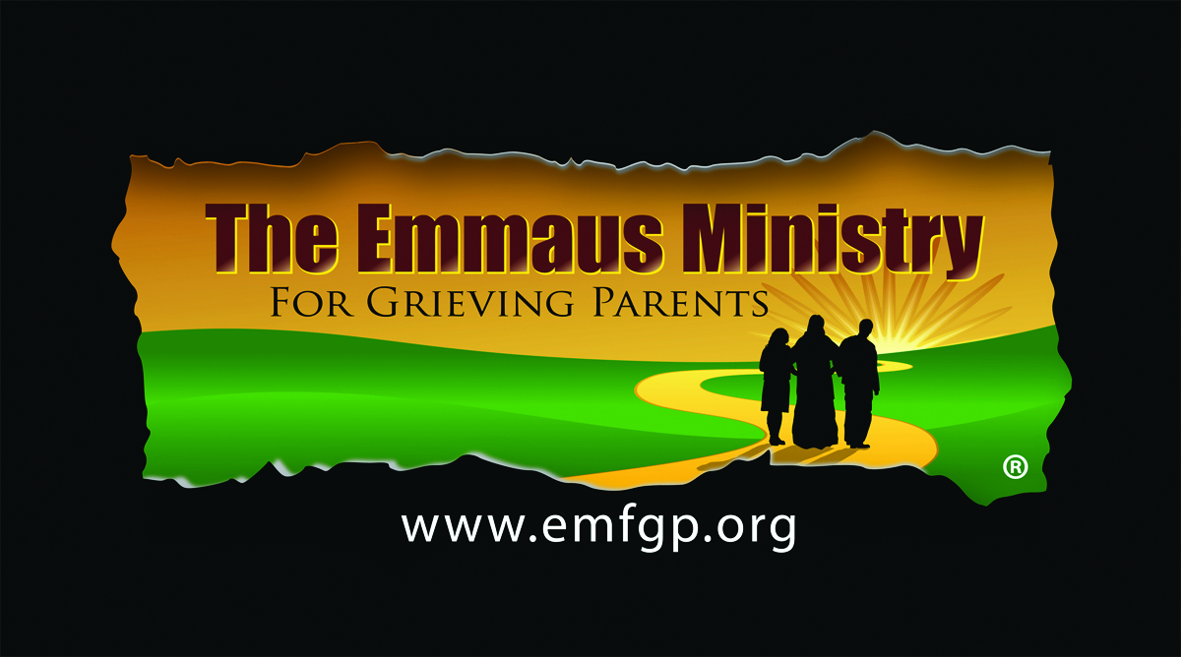

One-Day Retreat
October 15, 2016

It was an absolutely beautiful day today in Rhode Island in so many ways… from the stunning weather to the depths of emotions shared by parents who joined together at our second annual One-Day Emmaus Ministry Retreat for Grieving Parents at the Catholic Faith Communities of St. Theresa & St Christopher in Tiverton, RI.

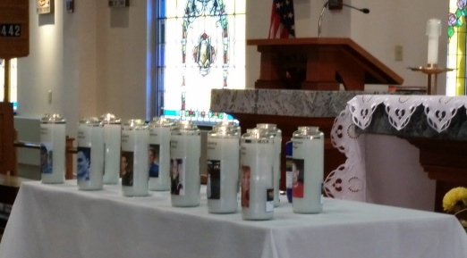
If you live in New England, you love these deep blue sky, colorful, leaf-peeping days of fall. Today was no exception. We arrived at St. Theresa’s bright and early, but most of the rest of the Retreat Team was already there.

We were preparing to serve the spiritual needs of grieving parent whose children of any age have died by any cause—no matter how long ago. At the retreat we welcomed new and returning parents from Portsmouth, Cumberland, Tiverton, and Warwick, RI; as well as East Sandwich, West Yarmouth, and Waltham, MA.

Time since the death of the child ranged from 31 years ago to 10 months ago. Age of children who died ranged from 5 months to 36 years old. Cause of death included illness, accident, malpractice, homicide, drug overdose, and suicide.

The Faith Communities of St. Theresa and St. Christopher—and Emmaus Ministry Parent Companions from past retreats—embraced the ministry and all of the parents who came with their loving, compassionate support:
- Fr. Shemek Lepak graciously hosted us at St. Theresa’s beautiful church and Parish Hall.
- Deacon Tim Flanigan gave a very moving homily on spiritual warfare and healing; he also served as Spiritual Leader for our Closing Prayer Service.
- Fr. Jason Brilhante, Chaplain, Charlton Memorial Hospital, gave our Reflection.
- Barbara Murray and Denise Carlucci served as Co-Coordinators of the retreat in loving memory of Melissa and Nicholas.
- Barbara Barry and Brenda Raposa were Parent Witnesses in loving memory of Michael and Craig.
- The Ladies Guild of St. Christopher’s tirelessly provided amazing food and sustenance throughout the entire day.
- Lucille Gince provided a delicious casserole.
- Parishioners and Friends of St. John Vianney Church in Cumberland, RI provided beautiful “Handmade Hug Prayer Shawls.”
- Local vendors, including BJ’s, Green Grocer, Subway, Shaw’s Market, and Dave’s Market, donated much needed food and nourishment.
- Other Retreat Team members included Beth Rapoza, Charley and Diane Monaghan, Pat Lidstone, Liz Pedro, and John Irwin.

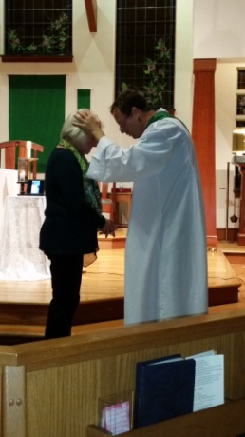
During a very moving Opening Prayer Service, Barbara and Denise emphasized the importance of the light of our candles, representing the Light of Christ and the light of our children in our lives, as well as the rebirth of their lives into Eternal Life.

We are still digesting Fr. Jason’s Reflection on “Redemptive Suffering” and how the seemingly unjust suffering that we, as parents have (which we don’t deserve)—when patiently and lovingly embraced, does indeed has redemptive and transformative power. We discussed… What does that really mean? How does choosing to accept pain and suffering bring us closer to Christ, as members of the Mystical Body?

Fr. Jason stated that he believes that somehow, someway, our suffering as parents here on earth does indeed help our children in heaven. Additional discussion ensued around the question of “What about parents who are not ready for the spiritually –mature concept of ‘redemptive suffering’?

Parent Witnessing was particularly poignant with Brenda and Barbara offering their testimonies. Brenda cited Wisdom 4:7 in her remarks:
“But the righteous man, though he die early, will be at rest. For old age is not honored for length of time, nor measured by number of years.”

Barbara emphasized that “God is good! God is love and His love surrounds us. His love pours over us like a waterfall.”

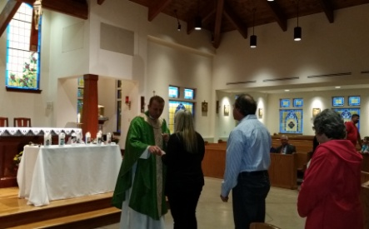
Afterwards in our Mother’s Groups we talked about how, as mothers, we need to “regulate self care,” shift priorities, and focus on compassion for others. We talked about having premonitions about our child’s death—particularly among mothers whose children died in car accidents. The day of the accident, several had the very real feeling of the impending death of their child. One mother had the premonition that her child would die young months before he actually did.

In our Father’s Group, we talked about how we are often treated by others as if we have a contagious disease—and about how hard it is to be a father of a child who has died, a child we swore to protect.

Our group of Emmaus Ministry for Grieving Parents was graciously welcomed to participate in the Saturday Vigil Mass of St. Theresa-St. Christopher Parishes. It was a beautiful experience, particularly at the end when Fr. Shemek invited us and the entire parish community to partake in the Sacrament of the Anointing. It was particularly meaningful after hearing Deacon Tim’s homily on the healing power of God’s love, something we parents need to hear over and over again.

After a delicious dinner provided by the Women’s Guild, we adjourned to the always moving Closing Ceremony when we experienced the laying on of hands by Deacon Tim and extinguished the flames our children’s candles, but never—their light and The Light of the World, which will continue until we are all together again forever.

