Appendix 24
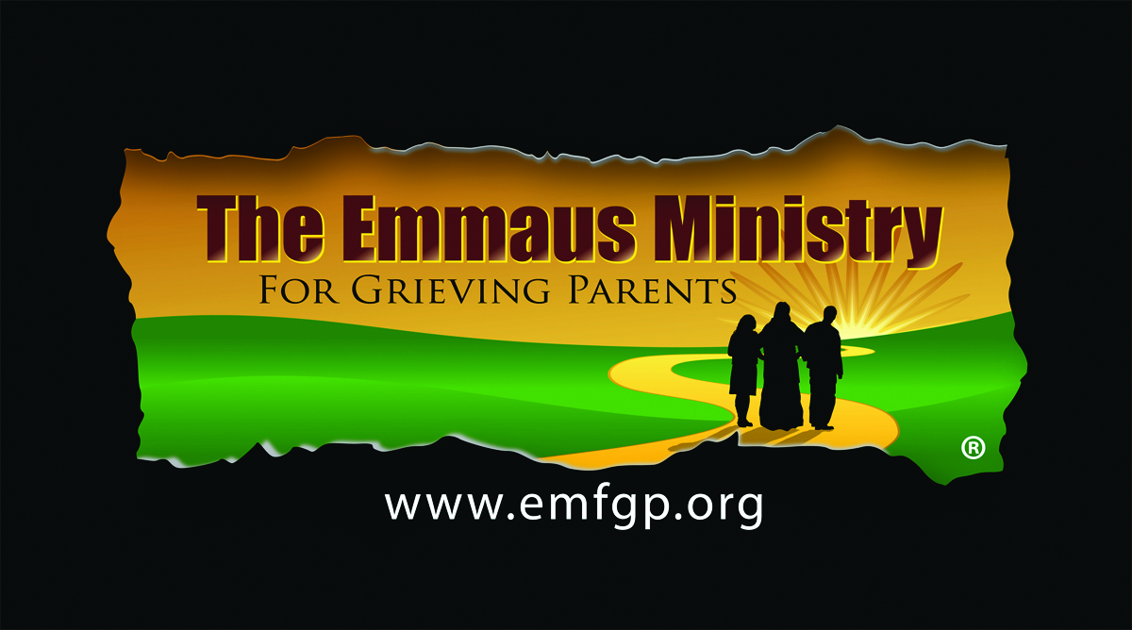

SAMPLE PROMOTIONAL MATERIALS TEMPLATES

- PARISH BULLETIN ADS
- PASTOR EMAIL SAMPLE
- PARISH PRESS RELEASE SAMPLE
- DIOCESAN BROCHURE SAMPLE
- BROCHURE INSERT SAMPLE
- DIOCESAN NEWSPAPER AD SAMPLE
- DIOCESAN NEWSAPER ARTICLE SAMPLE
- LOCAL NEWSPAPER ARTICLE SAMPLE

SAMPLE PARISH BULLETIN ADS

Serving the Spiritual Needs
of Grieving Parents

Losing a child under any circumstance is horrific. Focusing on the spirituality of the grieving process can help tremendously.
A ministry for parents whose children of any age have died by any cause, no matter how long ago.
Please join us. All are welcome.

Emmaus Ministry for Grieving Parents
At <Your Location>
One-Day Spiritual Retreat
<Your Date>
9:30am-7:30pm

For more information or to register,
Call < Your Parish/Site Liaison> at
<Parish Main Phone Number>
Or call <Your Retreat Registration Coordinator> at <Coordinator’s Phone Number>
Or see www.emfgp.org

Serving the Spiritual Needs
of Grieving Parents
mfgp.org

<Your Location>
Emmaus Ministry for Grieving Parents Whose Children of Any Age Have Died by Any Cause, No Matter How Long Ago
One-Day Spiritual Retreat
<Your Date>
Call <Your Phone Numbers>
Or see www.emfgp.org

SAMPLE EMAIL TO PARISHES REQUESTING PUBLICATION OF ADS

Dear Father:
Working with grieving parents whose precious children have died can be daunting. There are no words, and seemingly no comfort. Yet the promise of eternal life and the rich teachings of our Catholic faith can tremendously help these parents who need it so much.
Now available in <YOUR LOCATION>…
The Emmaus Ministry for Grieving parents, which serves the spiritual needs of Catholic parents whose children of any age have died by any cause, no matter how long ago, is now available in <YOUR LOCATION>. For more information on this unique ministry, see www.emfgp.org

We will be offering a One-Day Spiritual Retreat on < YOUR DATE> at <YOUR LOCATION>. All are welcome. To help us get the word out, please publish the attached ads several times in your bulletin, if possible. And post or distribute the attached Information Sheet.

We deeply appreciate any help you are able to give, as this is our only means of communication. On behalf of the many parents who will receive peace and some comfort from this retreat, thank you.

Many blessings,
<Your Name>

Attachments: Ads/Information Sheet

SAMPLE DIOCESAN/PARISH BROCHURE-OUTSIDE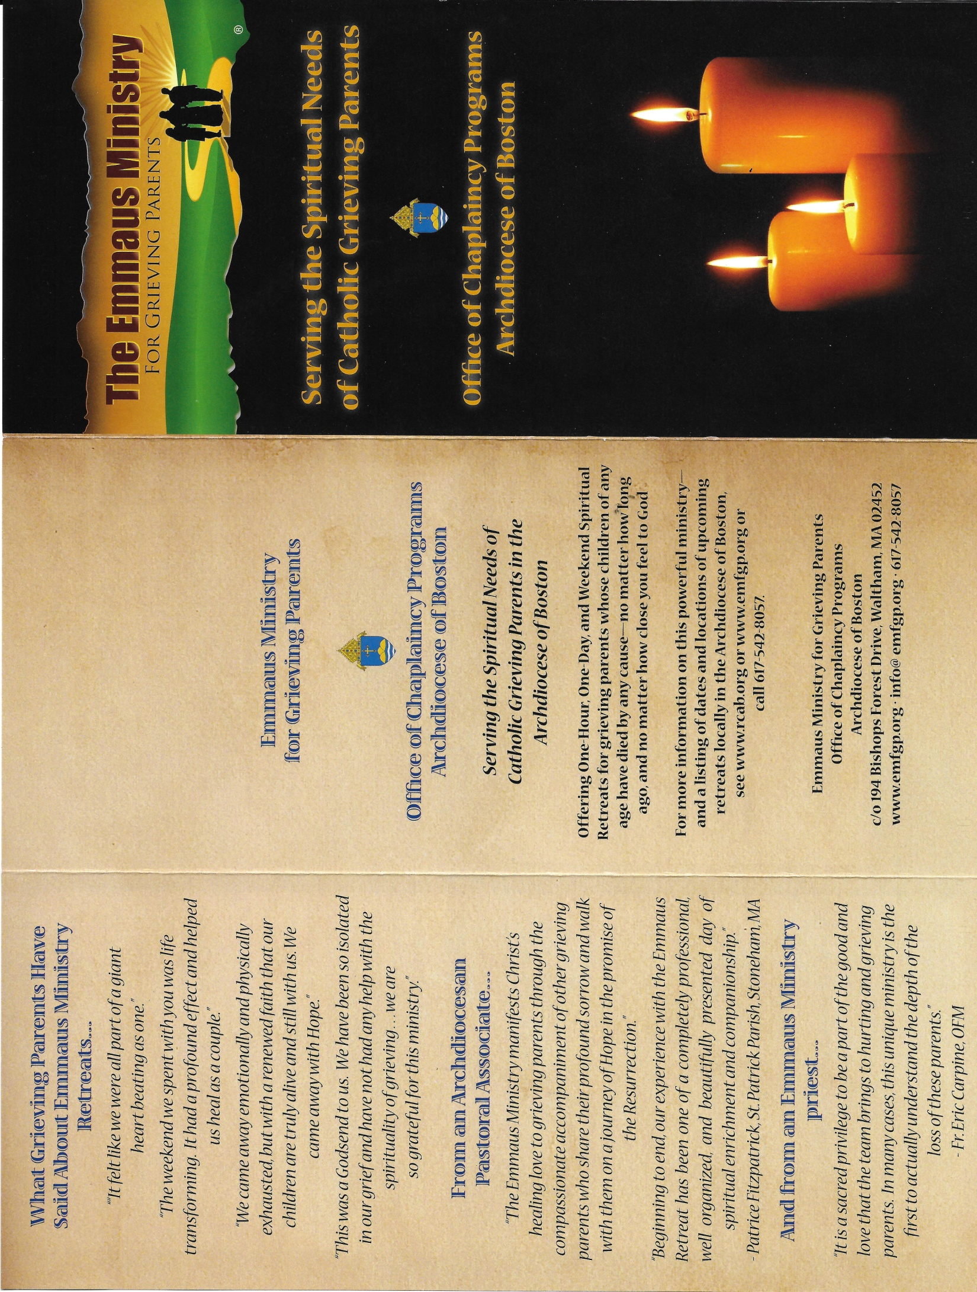
SAMPLE DIOCESAN/PARISH BROCHURE-INSIDE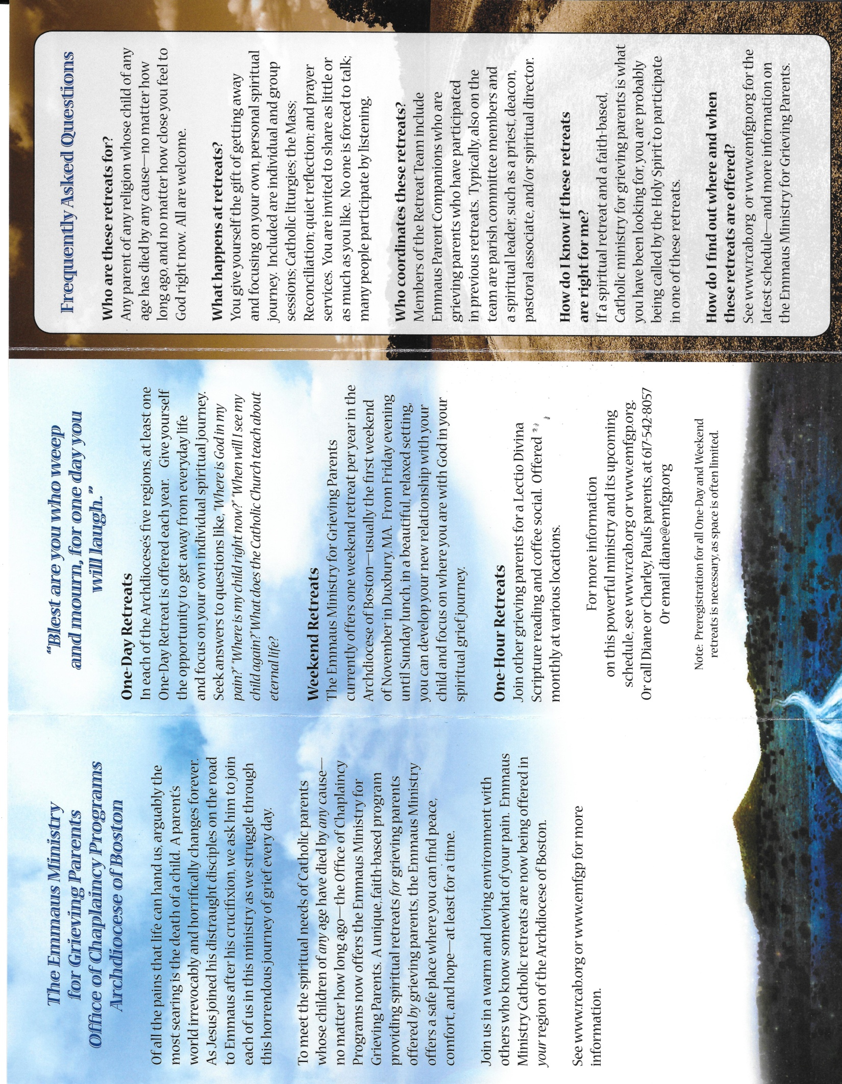
SAMPLE BROCHURE INSERT
(Bulletin ad resized to 3.5” x 8”)

<YOUR LOGO>
<YOUR LOCATION>

Serving the Spiritual Needs
of Grieving Parents

Losing a child under any circumstance is horrific. Focusing on the spirituality of the grieving process can help tremendously.

A ministry for parents whose children of any age have died by any cause, no matter how long ago.
Please join us.
All are welcome.

Emmaus Ministry for Grieving Parents
At <Your Location>
One-Day Spiritual Retreats
9:30am-7:30pm
<Your Date>
<Your Date>
<Your Date>

For more information or to register,
Call < Your Parish/Site Liaison> at
<Parish Main Phone Number>
Or call <Your Retreat Registration Coordinator> at <Coordinator’s Phone Number>

Or see www.emfgp.org

SAMPLE PRESS RELEASE

<Insert Your Logo Here>

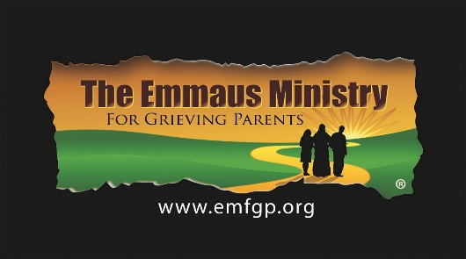

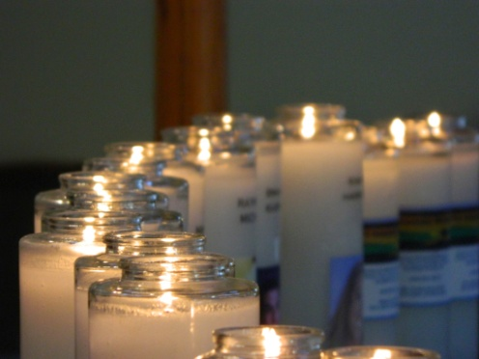

<Your Location> To Offer Spiritual Retreat for Grieving Parents
For more information, contact
<Your Contact Name> <Your Contact Phone Number>

Very few things in life are more painful than the death of one’s child. A parent’s life changes drastically and dramatically forever. Focusing on the spirituality of the grieving process and the very real promise of eternal life can help.

On <Your Date>, <Your Location> will offer a One-Day Spiritual Retreat for Grieving Parents at <Your Address> from 9:30am-7:30pm. The retreat is open to anyone whose child of any age has died by any cause, no matter how long ago. All are welcome, regardless of situation or religion.

This retreat is offered in cooperation with the <Your Diocese, if appropriate> and the Emmaus Ministry for Grieving Parents, a unique, ongoing Catholic program serving the spiritual needs of grieving parents. See www.emfgp.org or <Your website if you have retreat information on it> for more information. Or call <Your Contact> at <Your Location> at <Your Phone Number>.
###

SAMPLE DIOCESAN NEWSPAPER ARTICLE
1/18/17
Emmaus Ministry Retreats for Grieving Parents Offered in Archdiocese
By DAN PIETRAFESA
Marypat Hughes believes that the Emmaus Ministry for Grieving Parents can spiritually help parents cope with the pain of losing a child.
The Ossining woman led a spirited effort to bring the Catholic ministry to the archdiocese for three one-day Emmaus Ministry for Grieving Parents retreats at St. Joseph’s Seminary on Saturdays, Feb. 11 and 25, and the Church of the Magdalene in Pocantico Hills on Saturday, April 1.
“This will be meaningful for a lot of people on their journey,” said Ms. Hughes, who attended a retreat five months ago after her 29-year-old son Thomas James died in 2015.
“The prayer network that you engage in during the retreat stays with you. It’s very powerful.”
The three one-day retreats are serving as pilots for the program in the archdiocese with the goal to have the Emmaus Ministry for Grieving Parents available at parishes throughout the archdiocese.
The 10-hour pilot retreats will include group talks, the sacrament of reconciliation, Mass, prayer services and letter writing to God, child or another person.
The retreats open with a candle-lighting ceremony. Each candle has the child’s name and picture and stands as a symbol of constant prayer.
“We hope to have people come and get a few seeds out there to bring into their own parish. It’s the kind of ministry they found parishes rally around,” said Sue DiSisto, coordinator for parenting and family life in the archdiocese.
“I received a number of contact references and called around. Every comment heard was all extremely positive. It’s something very special for a group of people who are often having a hard time.”
Diane and Charley Monaghan, founders of the Emmaus Ministry, are scheduled to participate in the three New York retreats. The Monaghans, whose son Paul took his life on Thanksgiving Day in 2002, started Emmaus in Boston in 2009 with a mission to serve the spiritual needs of grieving parents whose children died at any age of any cause and to assist those interested in bringing this ministry to their parish or region. One-hour and one-day retreats are now held throughout the Northeast.
“You’re part of a club no one wants to be a part of,” Ms. DiSisto said. “Mothers and fathers grieve differently. This ministry is not a support or therapy group. It’s a spiritual journey.
“You really have a whole gamut of individuals coming to this to find healing spiritually in their walk and journey. A person can engage as much or as little as they want. Many people go to more than one of these retreats.”
Ms. Hughes’ son Thomas James, a Northwestern University graduate, was a successful investment banker for Moelis & Co. in Manhattan who turned to cocaine to cope with his professional demands. On May 28, 2015, Thomas fell to his death from his 24th-floor apartment in Manhattan. Signs of drinking and cocaine use were found in the apartment, police reported.
Ms. Hughes said attending bereavement group meetings at church were initially helpful. Feeling she needed more, she attended the Emmaus Ministry retreat in Boston in August.
She returned from the retreat and wrote a letter to Cardinal Dolan, hoping he’d bring this ministry to the archdiocese. The cardinal welcomed the idea and the archdiocesan Family Life/Respect Life is organizing the retreats.
“After this happens to you as a parent, you don’t know where to turn,” Ms. Hughes said. “When you’re in a room with other people who have been through this, you understand the glance from another person and where they’re coming from.”
Information: www.emfgp.org/archny or call (646) 794-3191.

SAMPLE LOCAL NEWSPAPER ARTICLE

St. Anthony Shrine’s Emmaus Ministry helps grieving parents go on

‘I felt like a load had been lifted’
Marie Szaniszlo Wednesday, October 19, 2016
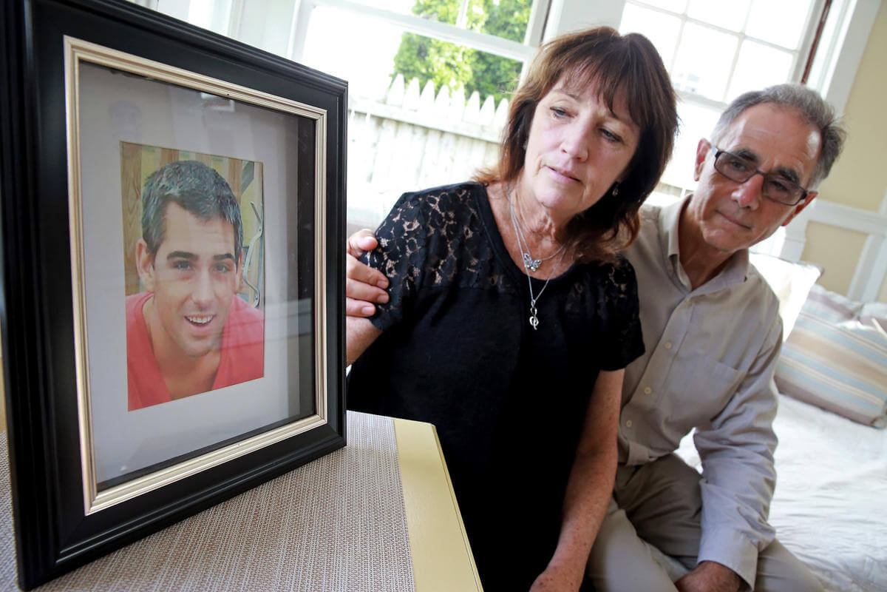

PROGRAM ‘HELPED SAVE ME’: Barbara and Rocco Favuzzi, above, look at a picture of their son, Dan, who killed himself in June 2014 at the age of 27. They found solace through the Emmaus Ministry for Grieving Parents at St. Anthony Shrine in Boston. Dan Favuzzi is seen at as a child in a photo at right.
STAFF PHOTOS BY MATT STONE

Boston Herald (MA)
Volume 34, Issue 293
October 19, 2016

VIDEO ON YOUTUBE AT https://www.youtube.com/watch?v=i470dpE6f7E

‘I felt like a load had been lifted’
Shrine’s Emmaus Ministry helps grieving parents go on

She still has all of his clothes. She doesn’t want to wash them. Their scent reminds her of him.

Photos of Barbara Favuzzi’s son are everywhere in the Scituate home she shares with her husband, Rocco, and their son’s dog, Axel. On the living room mantel is one of Dan at 17 in a blue shirt and beige tie, his dark hair peeking out behind his collar. And another of him at 26, his hair short and tinged with grey.
Upstairs, they keep the seven-string acoustic guitar they were going to give him as a birthday present before he killed himself on June 2, 2014, after a long struggle with drugs, alcohol, anxiety and depression. He was 27.

“From my perspective, that was the ultimate failure as a parent — everything you should have done, shouldn’t have done,” she said, her voice trailing off as she sits at the dining table.
After Dan died, his AA sponsor — one of the friars at St. Anthony Shrine in Boston — put her in touch with its Emmaus Ministry for Grieving Parents, and in October 2014, the Favuzzis went on their first Emmaus retreat.

“The Emmaus Ministry helped save me,” Barbara Favuzzi said. “It helped me realize there are some things that are out of your control. Forgive yourself. God gave you this child for however many years, and you did the best you could. Do the things your child would have wanted you to do. And one day, you’ll be together again.”

One of more than two dozen outreach programs at St. Anthony Shrine in Boston, the Emmaus Ministry offers parent-to-parent companioning, retreats, and monthly Scripture readings and coffee socials for parents whose children of any age have died by any cause.

Although the ministry focuses on the spiritual needs of grieving parents, for the Favuzzis, it also has had many of the benefits of a support group. They’ve developed friendships with other parents, swapped recipes and checked in with one another regularly, especially on their children’s birthdays.

On that first retreat, the Favuzzis were asked to write a letter to the child they had lost.
“I asked Dan to forgive me,” Barbara Favuzzi said, and she begins to cry. “As much as he and I talked, I couldn’t understand the depth of his pain.”

A nun at the retreat talked about prayer — to, not just for, their children — as a powerful conduit to peace. The group talked about Christ’s mother, Mary, who lost her own child when he was crucified, and about using her as a source of strength “because she would understand your pain better than anyone,” Barbara Favuzzi said.

“We talked about the spirit of your child still being with you, but in a different place, a place where eventually you’ll be together again,” she said. “By the next day, I felt like a load had been lifted off my shoulders.”

Rocco Favuzzi remembers initially finding that first retreat daunting.
“I probably wouldn’t have gone if it weren’t for my wife,” he said.

“When your child dies, you really don’t know what to do or where to turn. You build up a lot of hurt and guilt. But the (retreat’s) a place where you can release some of it without being put under any pressure to talk. You hear other people tell their stories, and you realize there are people there who’ve had similar experiences. Knowing that helps in its own way. It helps you not get over your loss, but get through it.”
Coming tomorrow: Unclaimed by any next of kin, the remains of three people who would otherwise have been buried in pauper’s graves are given funerals and burials with dignity and compassion by St. Anthony Shrine.
— marie.szaniszlo@bostonherald.com
Copyright (c) 2016 Boston Herald
Record Number: 31956403

