Serving the Spiritual Needs of Grieving Parents
<INSERT YOUR NAME OR LOGO HERE>
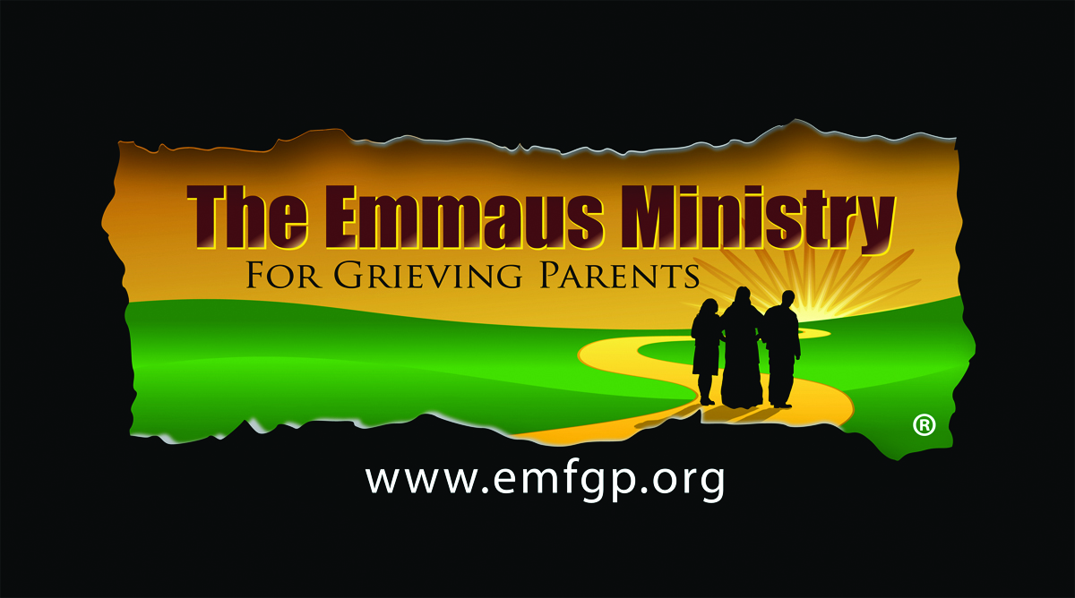

Saturday, <YOUR DATE>

A Spiritual One-Day Retreat for Parents Who Have Experienced the Death of
a Child of Any Age, By Any Cause, No Matter How Long Ago

Losing a child under any circumstances is horrific. Focusing on the spirituality of the grieving process can help tremendously. Just as He comforted His grieving disciples on the road to Emmaus, Jesus comforts us and we comfort each other in this very special ministry.

Join other Emmaus Parent Companions and our <YOUR NAME> Retreat Team in a warm and loving place—
to think, to talk, to feel, and to pray. Find compassion, rest, and peace… at least for a time.
___________________________________________________________________

Emmaus Ministry for Grieving Parents
At <YOUR NAME> in <YOUR LOCATION>

ONE-DAY SPIRITUAL RETREAT
<YOUR DATE> from 9:30am-7:30pm

All Are Welcome!

Donation: $25 Individuals; $40 Couples
Scholarships are available. Pre-registration is requested.

For more information, contact <YOUR RETREAT REGISTRATION COORDINATOR> at
<YOUR PHONE>
To register, complete the Registration Form at www.emfgp.org
Or use the Registration Form on the other side of this flyer and mail to
The Emmaus Ministry for Grieving Parents at <YOUR NAME>
<YOUR ADDRESS>

The Emmaus Ministry for Grieving Parents at <YOUR LOCATION>
<YOUR ADDRESS>
<YOUR PHONE,EMAIL, WEBSITE>



Name _________________________________________________________________

Address _________________________________________________________________
StreetCity StateZip

Phone __________________Email ___________________________________________

Please register me for the One-Day Emmaus Ministry Retreat at <YOUR NAME>:
Individual @ $25Total: $_______
Couple @ $40Total: $_______
Enclosed is my check payable to The Emmaus Ministry for Grieving Parents.

Be sure to send this Registration Form and your check as soon as possible to
The Emmaus Ministry for Grieving Parents at <YOUR NAME>
<YOUR ADDRESS>
Or
Register and pay online at www.emfgp.org

__________________________________________________

To speak to a grieving parent who has attended one of our programs,
Please call Diane or Charley, Paul’s parents, at (800) 919-9332

For more information on dates and locations for other upcoming programs,
See www.emfgp.org or email diane@emfgp.org

REGISTRATION FORM
The Emmaus Ministry for Grieving Parents
at <YOUR NAME>
<YOUR ADDRESS>
One-Day Spiritual Retreat
Saturday, <YOUR DATE> from 9:30am-7:30pm

The Emmaus Ministry for Grieving Parents at <YOUR NAME>
<YOUR ADDRESS>
<YOUR PHONE, EMAIL, WEBSITE>

