E



**ONE-DAY, IN-PERSON**

**EMMAUS MINISTRY   
SPIRITUAL RETREAT**

**FOR**

**GRIEVING PARENTS**

**SATURDAY**

**APRIL 1, 2023**

**9:30am -6:30pm CT**

**at**

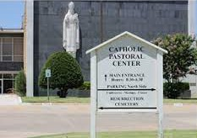

**Archdiocese of   
Oklahoma City   
Pastoral Center**

**7501 NW Expressway  
Oklahoma City OK, 73132**

For more information, call  
Dr. Alex Schimpf, Ph.D at  
405-709-2755

**PRE-REGISTRATION REQUIRED   
See** [**www.emfgp.org**](https://www.emfgp.org)