REVISED APPENDIX 23
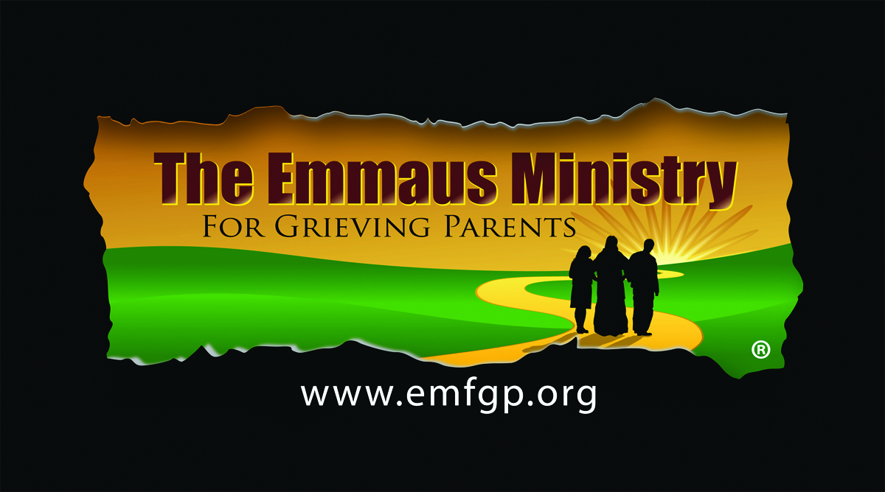
OTHER RETREAT ITEMS NEEDED

 | ITEM | RESPONSIBILITY  FOR YOUR INITIAL RETREAT  [EMFGP = We will bring]
 | ENVIRONMENT
1 | 15-20 boxes of tissues available in all meeting spaces and in the Sacred Space where candles will burn and where Prayer Services and Mass will be celebrated [Try to use tissue without lotion, as lotion causes teary eyes to burn.]
2 | CD player, MP3, Ipad or other method to play meditation music in the Sacred Space used to house Memorial Candles | EMFGP?
3 | Meditation music playlists or CD’s to be played during the Prayer Services and when the Sacred Space is not in use for Prayer Services or Mass, but candles are burning throughout the day | EMFGP?
4 | Six-foot table for Memorial Candles
5 | Six-foot table handouts
6 | Six-foot table for prayer shawls (if you are offering them)
7 | Cloth table cloths for Memorial Candles, Handouts, and Prayer Shawls tables
8 | Basket/container for Comfort Cross distribution
 | PROGRAM ACTIVITIES:
9 | A Paschal Candle, or in its absence, a sanctuary candle substituting for the Paschal Candle, representing the Light of Christ and from which all other candles will be lit
10 | For Opening and Closing Prayer Services, a brass candle lighter with bell snuffer, typically used by altar servers in parishes | EMFGP
11 | Wax lighting tapers for candle lighter | EMFGP
12 | If you plan to use incense in either the Mass or Closing Prayer Service:
12a | - Thurible and censer boat with spoon
12b | - Quick lite charcoal
12c | - Incense
13 | A method to call participants back to activities—a singing prayer bowl or bell of some sort* | EMFGP
14 | If you plan to do parent letter writing and to burn the letters to be offered with incense:
14a | - Paper and pens for writing. NOTE: we suggest using resume paper or some other high cotton content paper for the letters. We have found that this burns best into fine ash, while normal copy paper does not. You might want to try burning a piece of the paper you plan to use to determine that it does indeed burn to ash.
14b | - An appropriate receptacle in which to collect the completed letters (You can reuse the basket or container used for the Comfort Crosses)
14c | - A metal bucket or a large disposable aluminum casserole pan in which to burn the letters
14d | - An appropriate receptacle to hold the burned ash of parents’ letters (we will use our –or your—prayer bowl) | EMFGP
15 | Business-card-sized pieces of paper folded in half containing each retreatant’s name. These will be used to draw names for small group discussion and the Emmaus Walk.
16 | An appropriate receptacle in which to deposit the above single names, from which they will be prayed over and drawn before the small group discussion or Emmaus Walk. (You can reuse your basket or container for the Comfort Crosses.)
17 | Preparing name tags and candles for Walk-Ins:
 | - 1-3 blank name tags with Emmaus graphic
17a | - 1-3 blank candles with extra candle back labels to affix if necessary
17b | - Scissors to cut photocopies of photos parents bring with them to size; double face tape to affix photo to candle
17c | - Extra blank Avery #22822 clear labels to handwrite child’s name and affix on candle
18 | Optional: prayer shawls

*You can purchase a 7"diameter brass singing prayer bowl online for about $50. We use it for multiple purposes, including Appendices #13a and b, #14b & d

