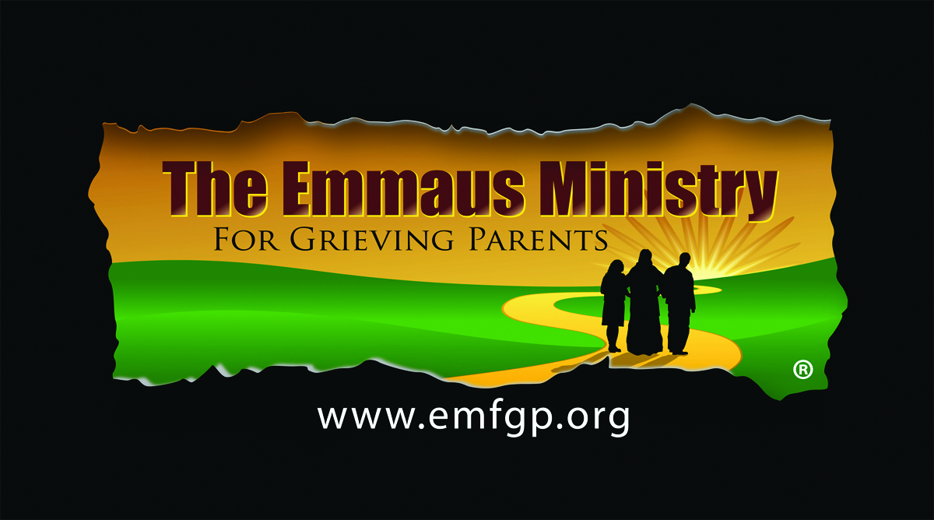

**ONE-DAY SPIRITUAL RETREAT**

**SATURDAY, APRIL 29, 2023**

**Mary Queen of Martyrs Parish**

**Our Lady of Lourdes, Carver, MA**

*Losing a child under any circumstance is devastating.*

*Focusing on the spirituality of the grieving process*

*can help tremendously. The Emmaus Ministry is for parents whose children of any age, have died by any cause, no matter how long ago*.

**Please join Fr. Joseph Raeke and other parent companions at**

**Mary Queen of Martyrs Parish**

**Our Lady of Lourdes**

**130 Main St. Carver, MA**

**9:30am-6:30pm**

Retreat agenda includes prayer services, spiritual reflections,  
breakout sessions, Emmaus Walk, Mass, and time for reflection

The purpose of the retreat is to give yourself this gift of time on your spiritual journey and consider… Where is God in my pain?…Where is my child now?… How can my faith help me through this new reality of life without my child?

**Pre-Registration is required**

**For more information or to register, please contact**

**Susanne Conley 774-454-9091**

**Learn more at www.emfgp.org**