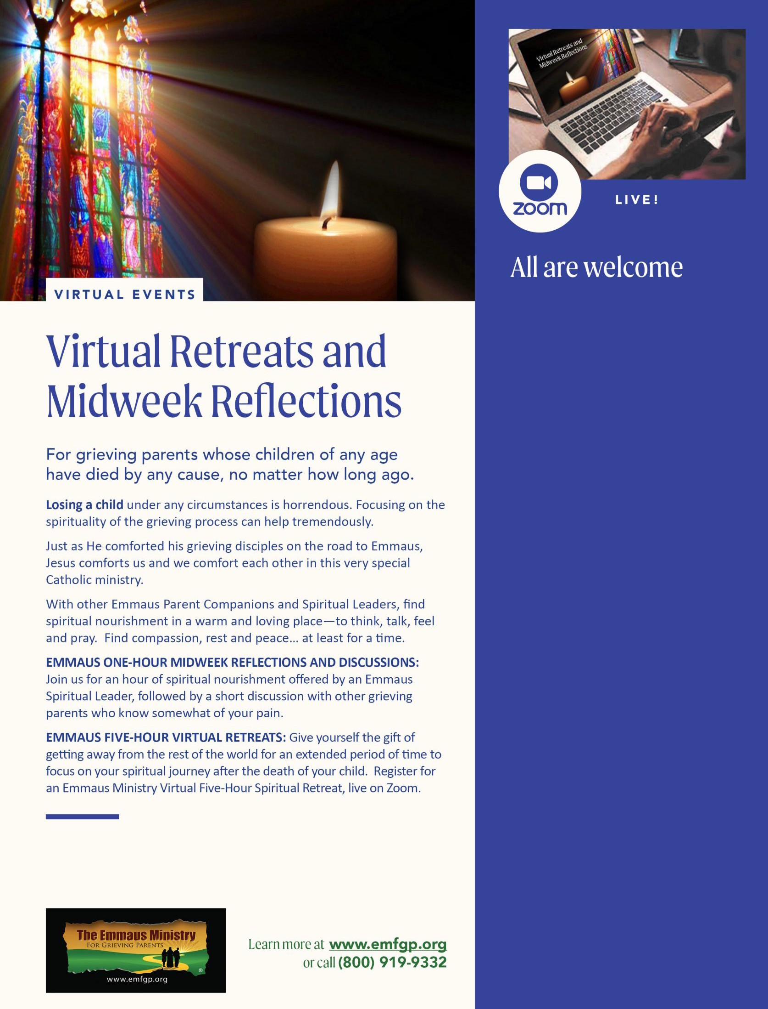

**2023   
MONTHLY MIDWEEK   
GATHERING RETREATS**

**[JOIN US!](https://www.emfgp.org/09-13-23-midweek-gathering-registration-form/)**

# Ann Arra.jpg

# Ann Arra, Michael’s Mother

# ONE-HOUR MIDWEEK GATHERING RETREAT

**September 12, 2023   
 8pm-9pm ET  
via ZOOM**

**Offered by the  
Archdiocese of Boston**

**Hear about the evolution of Ann’s spiritual journey after the sudden death of her son, Michael**

[**REGISTER TODAY!**](https://www.emfgp.org/06-14-23-archdiocese-of-boston-midweek-gathering-registration-form/)