E

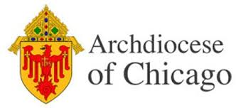

**ONE-DAY**

**EMMAUS MINISTRY   
SPIRITUAL RETREAT**

**FOR**

**GRIEVING PARENTS   
whose children of any age   
who have died by any cause,   
no matter how long ago**

**SATURDAY**

**OCTOBER 5, 2024**

**9:30am -7:00pm**

**at**



**St. Joseph Campus**

**1747 Lake Avenue  
Wilmette, IL 60091**

**ALL ARE WELCOME!**

**For more information, contact  
Zoe Hoeppner, August’s Mother   
at cz.hoeppner@gmail.com  
or**

**773-251-8989**

[**PRE-REGISTRATION REQUIRED**](https://www.emfgp.org/10-05-24-archdiocese-of-chicago-registration-form/)  **See www.emfgp.org.**