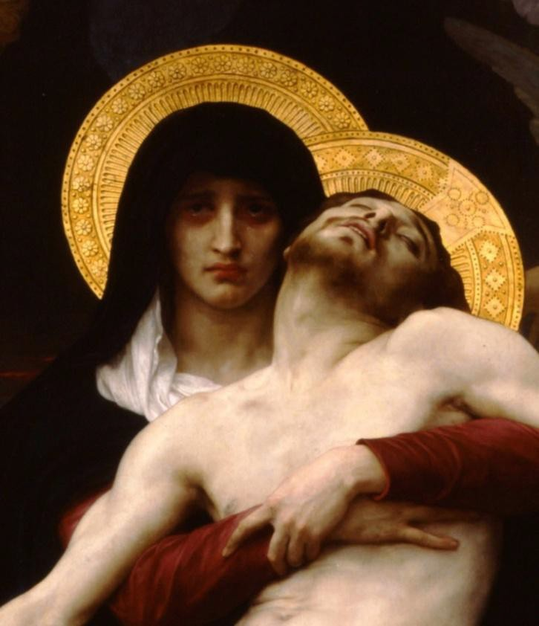
Pilgrims of Hope We Are

In response to Pope Francis’ call to console the sorrowing during this Jubilee Year of Hope

Masses for Grieving Parents
on the Feast of
Our Lady of Sorrows
September 15, 2025
Please join us at any of these Masses celebrated in honor of
Our Lady of Sorrows, our patron saint,
for the intentions of “All Grieving Parents.”
Spread devotion to Our Lady by distributing
free devotional cards at these masses.
Order cards at www.emfgp.org/ols-mass.

LOCATION | ADDRESS | TIME
MASSACHUSETTS
St. Mary Parish | 133 School St., Waltham, MA | 12:10pm ET
St. Anthony Shrine | 100 Arch St., Boston, MA | 12:05pm ET
St. Camillus Parish | 1185 Concord Turnpike, Arlington, MA | 9:00am ET
St. Katari Parish | 126 South Meadow Rd, Plymouth, MA | 9:00am ET
Most Holy Redeemer* | 65 London Street, East Boston, MA | 7:00pm en español
Resurrection Parish | 1057 Main Street, Hingham, MA | 7:30am
Immaculate Conception Church* | 111 Prospect Street, Marlborough, MA | 7:30am
Holy Rosary Shrine* | 34 Common Street, Lawrence, MA | 12:05pm
St. Patrick Church* | 335 Main Street, Brockton, MA | 9:00am
*Jubilee pilgrimage church

