Be a Pilgrim of Hope

This Jubilee Year, Pope Francis has asked us to console the sorrowing on **September 15, 2025,**

**the Feast of**

**Our Lady of Sorrows**

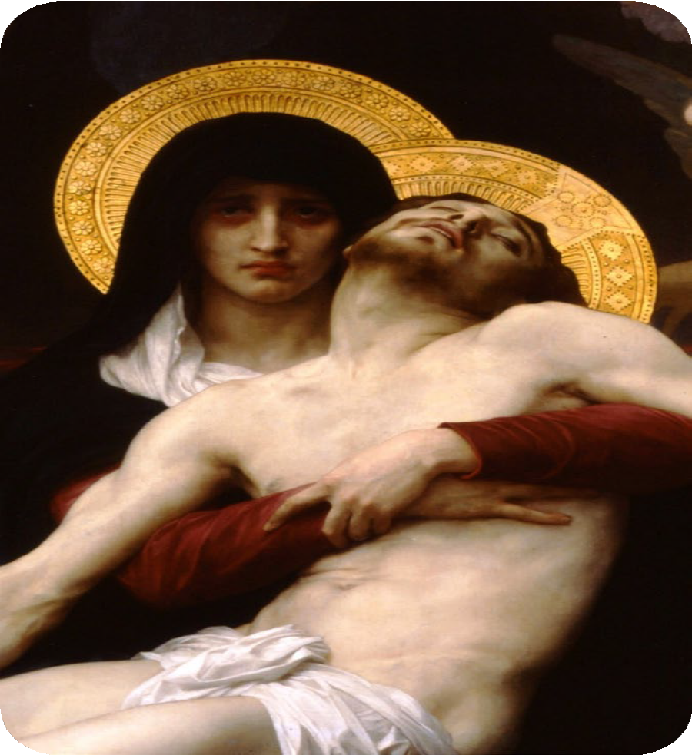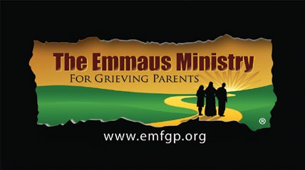

# Hosted by:

**Learn more about the Jubilee Year and events in the Archdiocese of Boston at** [**bit.ly/JubileeOfHope**](https://bit.ly/JubileeOfHope)**.**

# Here’s How:

1. **Have a Mass said on September 15, 2025 for “Those who need consoling.” Then, share the Mass information (**[**bit.ly/OLSorrowsMass**](http://bit.ly/OLSorrowsMass)**) to encourage others to attend.**
2. **Console those who mourn.**
3. **Share Our Lady of Sorrows devotional cards. (Available for free at** [**bit.ly/OLSorrowsMass**](http://bit.ly/OLSorrowsMass)**.)**
4. **Learn about and practice a devotion to the Seven Sorrows of Mary.**