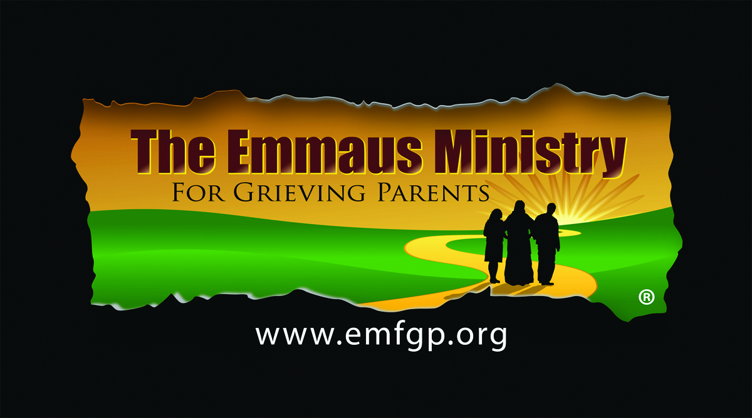

***Serving the Spiritual Needs***

***of Grieving Parents***

Losing a child under any circumstance is horrific. Focusing on the spirituality of the   
grieving process can help tremendously.

A ministry for parents whose children of any age   
have died by any cause, no matter how long ago.

Please join us. All are welcome.

**Emmaus Ministry for Grieving Parents**

**at St. Thomas More Parish  
Appleton, WI**

**One-Day Spiritual Retreat**

**Saturday, October 25, 2025**

**9:30am-6:30pm**

For more information, call  
Sheila Re at 920-272-8283   
or  
Diane Monaghan, Paul’s Mom, at 800-919-9332

Or see www.emfgp.org

**St. Thomas More Parish  
Appleton, WI  
Emmaus Ministry for Grieving Parents Whose Children of Any Age Have Died by Any Cause, No Matter How Long Ago**

**One-Day Spiritual Retreat**

**October 25, 2025**

**Call 920-272-8283 or 800-919-9332**

**Or see www.emfgp.org**