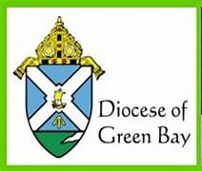

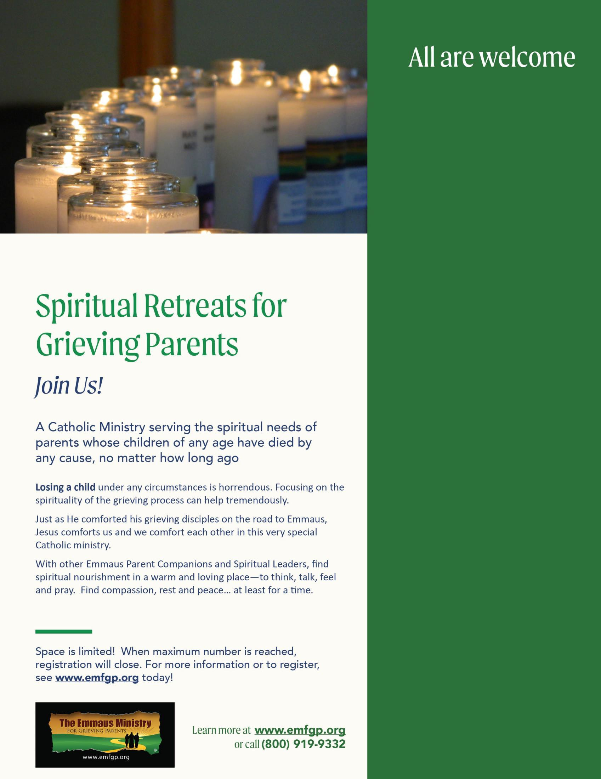

E

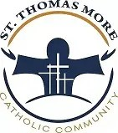

**Diocese of Green Bay  
St. Thomas More Parish**

**1810 N. McDonald St, Appleton, WI**

**ONE-DAY EMMAUS MINISTRY SPIRITUAL RETREAT**

**FOR GRIEVING PARENTS**

**whose children of any age who have died by any cause, no matter how long ago**

Saturday, October 25, 2025

9:30am -6:30pm

ALL ARE WELCOME!  
JOIN US!

For more information, contact   
Sheila Re at 920-272-8283   
and sre@gbdioc.org   
or Diane Monaghan, Paul’s Mom  
at 800-919-9332 and  
diane@emfgp.org