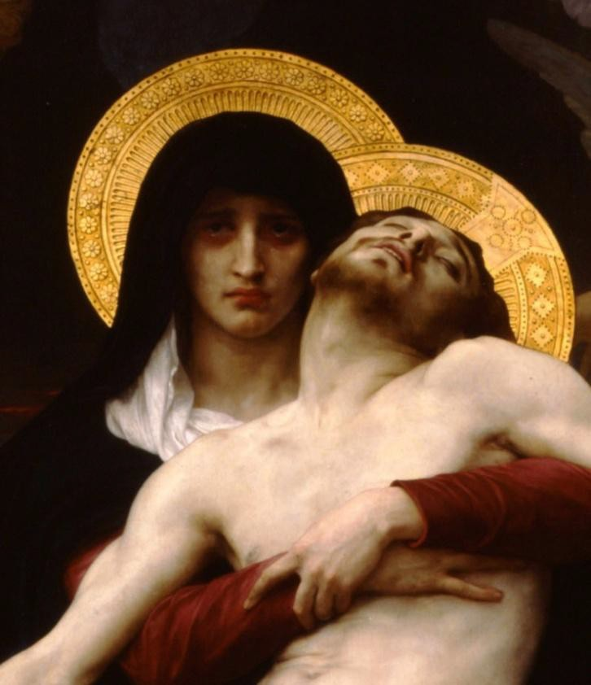

Pilgrims of Hope We Are

**For Those   
Who Need Consoling**

**on the Feast of   
Our Lady of Sorrows   
September 15, 2025**

Please join us at any of these Masses celebrated in honor of Our Lady of Sorrows,   
the Patron Saint of the Emmaus Ministry for Grieving Parents, for the intentions   
of all those who need consoling, particularly grieving parents.

Learn how you can participate in this ongoing devotion to Our Lady of Sorrow and receive her graces.

|  |  |  |
| --- | --- | --- |
| **LOCATION** | **ADDRESS** | **TIME** |
| **ARCHDIOCESE OF BOSTON** |  |  |
| **CENTRAL REGION** |  |  |
| Most Holy Redeemer* | 65 London Street, East Boston, MA | 7:00pm en español |
| St. Anthony Shrine | 100 Arch Street, Boston, MA | 12:10pm |
|  |  |  |
| **MERRIMACK REGION** |  |  |
| Holy Rosary Shrine* | 34 Common Street, Lawrence, MA | 12:05pm |
| Our Lady of Good Counsel | 22 Plymouth Street, Methuen, MA | 12:00pm |
|  |  |  |
| **NORTH REGION** |  |  |
| St. John Paul II Shrine of Divine Mercy* | 28 St. Peter Street, Salem, MA | 7:00pm |
| St. Camillus Parish | 1185 Concord Turnpike, Arlington, MA | 9:00am |
| St. Raphael Parish | 516 High Street, Medford, MA | 7:00pm |
|  |  |  |
| **SOUTH REGION** |  |  |
| St. Patrick Church* | 335 Main Street, Brockton, MA | 9:00am |
| St. Katari Parish | 126 South Meadow Rd, Plymouth, MA | 9:00am |
| Resurrection Parish | 1057 Main Street, Hingham, MA | 7:30am |
|  |  |  |
| **WEST REGION** |  |  |
| Immaculate Conception Church* | 111 Prospect Street, Marlborough, MA | 7:30am |
| St. Mary Parish | 133 School St., Waltham, MA | 12:10pm |
|  |  |  |

*Jubilee Pilgrimage Church

|  |  |  |
| --- | --- | --- |
| OTHER DIOCESES |  |  |
| St. Pius X Parish | 5 Barbara Street, South Yarmouth, MA | 8:00am |
| St. Mary Parish | One Power Street, Norton, MA | 9:00am |
| Lumen Christi | 2055 Bohland Avenue, St. Paul, MN | 10:30am |
| St. Bernadette Parish | 70 University Blvd E, Silver Spring, MD | 5:00pm |
| Queen of Martyrs Pastorate | 2222 Shopier Road, Beloit, WI | 12:00pm |
|  |  |  |
|  |  |  |
|  |  |  |
|  |  |  |
|  |  |  |
|  |  |  |