Pilgrims of Hope  
Were We!  
All over the world   
this Jubilee Year,   
we remembered  
Grieving Parents

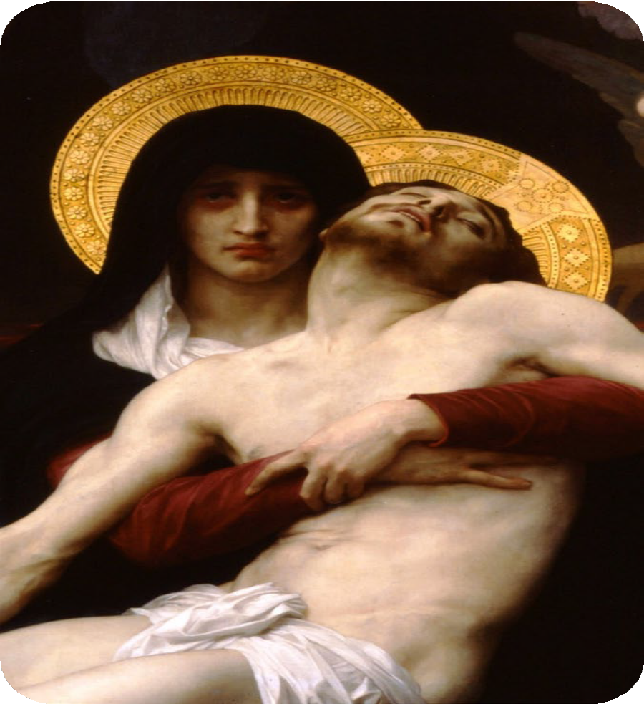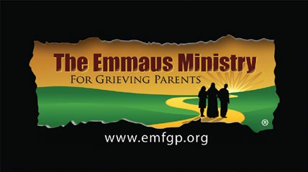

September 15, 2025  
Feast Day of   
The Emmaus Ministry’s   
Patron Saint,  
Our Lady of Sorrows

Sponsored by:

**PILGRIMS OF HOPE WERE WE   
THIS JUBILEE YEAR OF HOPE.  
THANKS TO ALL!**

# 

# THANK YOU!

**Almost 70 Masses and mini-retreats were celebrated internationally on 09/15/25   
in honor of   
Our Lady of Sorrows   
for the intention of   
“*All in Need of Consolation, Especially Grieving Parents*.”**

**For a list of 2025 Masses, see**[**www.emfgp.org/ols-mass-locations**](http://www.emfgp.org/ols-mass-locations)

JOIN US AGAIN IN 2026!